新型冠状病毒信息指南

什么是新型冠状病毒？

2020年1月上旬中国发现了首例新型冠状病毒（也称冠状病毒）。其他国家如韩国、泰国、日本、台湾、美国和澳大利亚也相继出现了病例。澳大利亚已发现五例。堪培拉尚未发现病例。

新型冠状病毒的症状

该病毒可引起轻度疾病到肺炎等一系列症状。受影响的人可能会出现：
•发烧
•感冒症状如咳嗽、喉咙痛和头痛
•呼吸困难

如何预防新型冠状病毒

每个人都应采取卫生和其他措施以防感染：
•洗手
•咳嗽或打喷嚏时捂住嘴
•避免与野生或农场动物接触

如果您在外旅行：
•避免与病人接触
•定期洗手
•戴口罩
•避免在触摸其他东西后触摸脸和嘴

如何诊断

如果某人符合以下流行病学和临床标准，则可将其定为可疑病例。

流行病学标准: 发病前14天前往武汉（中国湖北省）; 或发病前14天内，前往有持续的人传人及已宣布爆发疫情的地区;或发病前14天与确诊病例有密切接触。
临床标准: 发烧或有发烧史（高于38°C）和急性呼吸道感染（呼吸道感染突然发作，且至少有呼吸急促，咳嗽或喉咙痛其中一种症状）;或有严重的急性呼吸道感染需要住院治疗，并有肺炎或急性呼吸困难综合征的临床或放射学证据（即使无发热迹象）。

经医疗人员评估后，将对可疑病例进行病毒检测，还可能需要照X光胸片。

如果感到不适该怎么办？

如果您感到不适，并怀疑您可能患有冠状病毒症状，必须寻求医疗帮助。请提前打电话给您的全科医生或急诊室预约看病。这将帮助您的医生了解您的症状和旅行史，医生还会提供就医注意事项。
如果您需要紧急医疗帮助，请致电000。

有关冠状病毒更多和最新信息，请访问澳大利亚卫生部网站：https://www.health.gov.au/health-topics/novel-coronavirus-2019-ncov
Coronavirus Information Guide

What is novel coronavirus?
The first new novel coronavirus (also known as coronavirus) case was identified in China in early January 2020. Health authorities have identified the coronavirus cases in China, South Korea, Thailand Japan, Taiwan, the United States, and Australia. Five cases have been reported in Australia. Canberra currently has no cases.

Symptoms of novel coronavirus
The virus can cause a range of symptoms from mild illness to pneumonia. Affected people may experience:
- fever
- flu like symptoms such as coughing, sore throat and headaches
- difficulty breathing

How you can help prevent novel coronavirus
Everyone should practise hygiene and other measures to protect against infections:
- washing your hands
- covering your mouth while coughing or sneezing
- avoiding contact with wild or farm animals
If you are travelling:
- avoid contact with sick people
- regularly wash your hands
- wear mask
- avoid touching your face and mouth after touching surfaces

Diagnosis
A person is classified as a suspected case if they meet certain criteria.
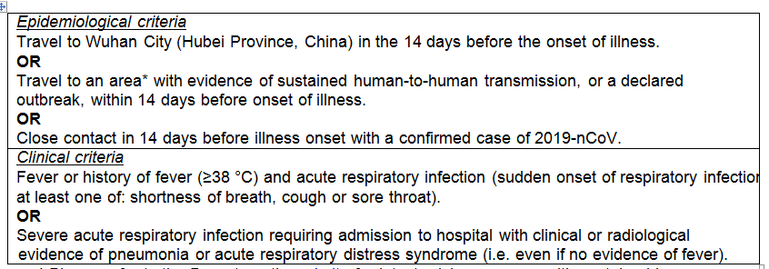
After being assessed by a health professional, a suspected case will be tested for the virus. They might also order a chest x-ray.

What to do if you become unwell
If you become unwell and suspect you may have symptoms of coronavirus, you must seek medical attention. Please ring ahead of time to book your appointment with your GP or Emergency Department. This will help make your doctor aware of your symptoms and your travel history.
Call 000 if you need urgent medical help.
For more information and the latest update on coronavirus, please visit the Department of Health website: https://www.health.gov.au/health-topics/novel-coronavirus-2019-ncov

